Theoretical Competition
– Exam Sheet –
December 6, 2015
Do NOT turn to next page
before a whistle is blown.
Otherwise, you will receive a penalty.

1. You have 5 minutes to read “EXAMINATION RULES”, “EXAM INSTRUCTIONS”, and “CALCULATOR INSTRUCTIONS” on pages 1 - 3.

2. Do NOT start answering the questions before the“START”whistle is blown! Otherwise, you will receive a penalty.

EXAMINATION RULES

1. You are NOT allowed to bring any personal items into the examination room, except for personal medicine or approved personal medical equipment.
2. You must sit at your designated desk.
3. Check the stationery items (pen, calculator, and rough book) provided by the organizers.
4. Do NOT start answering the questions before the “START” whistle.
5. You are NOT allowed to leave the examination room during the examination except in an emergency in which case you will be accompanied by a supervisor/volunteer/invigilator.
6. Do NOT disturb other competitors. If you need any assistance you may raise your hand and wait for a supervisor to come.
7. Do NOT discuss the examination questions. You must stay at your desk until the end of the examination time, even if you have finished the exam.
8. At the end of the examination time you will hear the “STOP” whistle. Do NOT write anything more on the answer sheet after this stop whistle. Arrange the exam, answer sheets, and the stationary items (pen, calculator, and rough book) neatly on your desk. Do NOT leave the room before all the answer sheets have been collected.

EXAM INSTRUCTIONS

1. After the “START” whistle, you will have 3 hours 30 minutes to complete the exam.
2. ONLY use the pen provided by the organizers (not pencil).
3. You have 13 pages of answer sheets. Raise your hand, if you find any missing sheets.
4. NOW write your name, code, country and signature in your first answer sheet, and your name and code in the next pages of your answer sheets.
5. Read carefully the problems and write the correct answers in the corresponding boxes of the answer sheet.
6. When units are provided in the answer sheets, you have to write the answers correctly for the units.
7. Only the answer sheets will be evaluated. Before writing your answers on the answer sheets, use the rough book provided.
8. Point rules : Each question marking
9. The total number of questions is 6. Check that you have a complete set of the test questions sheet (12 pages, page 5 – page 16) after the “START” whistle is blown. Raise your hand, if you find any missing sheets.

CALCULATOR INSTRUCTIONS

1. Turning on: Press .
2. Turning off: Press .
3. Clearing data: Press .
4. Addition, subtraction, multiplication, division
Example 1) $45+\frac{285}{3}$
45 285 3 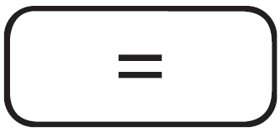 140.
Example 2) $\frac{18+6}{15-8}$
18 6 15 8 3.428571429
Example 3) $42×\left(-5\right)+120$
42 5 120 -90.
42 5 120 -90.
5. Exponential
Example 1) ${8.6}^{-2}$
8.6 2 0.013520822
Example 2) ${6.1 × 10}^{23}$
6.1 10 23 6.1 x 10²³
6. To delete a number/function, move the cursor to the number/function you wish to delete, then press . If the cursor is located at the right end of a number/function, the key will function as a back space key.

Do NOT turn to next page
Before the “START” whistle is blown.
Otherwise, you will receive a penalty.

I. Chemical Oxygen Demand (COD) Test

The chemical oxygen demand (COD) test is commonly used for indirectly measuring the amount of organic compounds in water. Most applications of COD are related to determining the amount of organic pollutants found in surface water (e.g. lakes and rivers) or wastewater, making COD a useful measure of water quality. It is expressed in ppm (parts per million), which indicates the mass of oxygen molecules (in mg) consumed for oxidizing the pollutants per liter of solution. The basis for the COD test is that nearly all organic compounds can be fully oxidized to CO₂ with a strong oxidizing agent under acidic conditions.

The amount of oxygen molecules required to oxidize an organic compound to CO₂ and water is given by:
(1)
Potassium dichromate (K₂Cr₂O₇) is a strong oxidizing agent and is used to oxidize organic compounds in the COD determination under acidic conditions. The net reaction of K₂Cr₂O₇ with an organic compound is given by:
(2)

The general procedure for the COD test can be described as follows.

(A) A solution of K₂Cr₂O₇ (with a known concentration) is added to a solution containing organic pollutants. K₂Cr₂O₇ oxidizes the organic pollutants by the reaction (2).
(B) After completely oxidizing the organic pollutants, the remaining [K₂Cr₂O₇] is determined by titration with Fe²⁺. In the titration, Fe²⁺ is oxidized to Fe³⁺ and Cr₂O₇²⁻ is reduced to Cr³⁺. This titration will let you know the amount of Cr₂O₇²⁻ used to oxidize the pollutants in the solution.
(C) Using the amount of K₂Cr₂O₇ obtained in step (B), the theoretical amount of oxygen molecules required to oxidize the same amount of the pollutants can be calculated by comparing x and y in equations (1) and (2). This is called COD.

[Questions]

I-1. To determine the COD from the consumed K₂Cr₂O₇ for oxidizing organic pollutants, the mole ratio between O₂ and K₂Cr₂O₇ for oxidizing 1 mole of organic pollutant is required. The mole ratio can be determined by comparing x and y in equations (1) and (2) after balancing them. The following procedure is useful.

I-1-1. [0.5 points] Express x in terms of a, b, and c by balancing the equation (1).
I-1-2. [0.5 points] Express z in terms of y by balancing the charge in the equation (2).
I-1-3. [0.5 points] Express y in terms of a, b, and c by balancing the equation (2).
I-1-4. [0.5 points] Express x in terms of y by comparing your answers.

I-2. To determine the COD of an aqueous solution containing an unknown pollutant, mol of K₂Cr₂O₇ was added to 10.0 mL of the pollutant solution. After the oxidation was completed, mol of Fe²⁺ was required to titrate the remaining K₂Cr₂O₇.

I-2-1. [1.0 point] In the following balanced equation for the reaction between Cr₂O₇^{2–} and Fe²⁺ in acidic media, what is the coefficient f?
I-2-2. [1.0 point] How many moles of K₂Cr₂O₇ were consumed for oxidizing the pollutants in 10.0 mL of the polluted solution?
I-2-3. [1.0 point] What is the COD of the unknown sample in ppm? The molecular mass of O₂ is 32.0 g/mol.
I-2-4. [2.0 points] If the unknown pollutant was C₆H₆, what was the amount of pollutant in milligrams per liter of solution and the volume of CO₂ produced during the complete oxidation of the 1.00 liter solution at 298 K and 1.00 atm. Molecular mass of C₆H₆ is 78.0 g/mol and the gas constant R = 0.0821 L·atm/mol·K. (Assume that CO₂ is an ideal gas.)
I-2-5. [1.0 point] How many moles of Cr³⁺ existed right before and after the titration with Fe²⁺?

I-3. [2.0 points] When 10 mg of each of the following compounds is completely dissolved in 1.0 L of water, which compound produces the highest COD and what is its COD value? (The atomic masses of C, H, and O are 12, 1.0, and 16 g/mol, respectively.)

HCOOH (formic acid) | CH₃OH (methanol) | CH₃CHO (acetaldehyde)
II. Ski Jumping

The 2018 Winter Olympics will take place on February 2018, in PyeongChang, Republic of Korea. One of the Winter Olympic competitions is ski jumping, where the skier descends a specially constructed take-off ramp (known as the in-run), then jumps from the launcher (jumping point) with as much speed as he/she can generate, and flies as far as possible down a steeply sloped hill. Figure II-1 shows an outline of a ski jumping hill, divided into four parts: in-run, jump, flight, and landing.

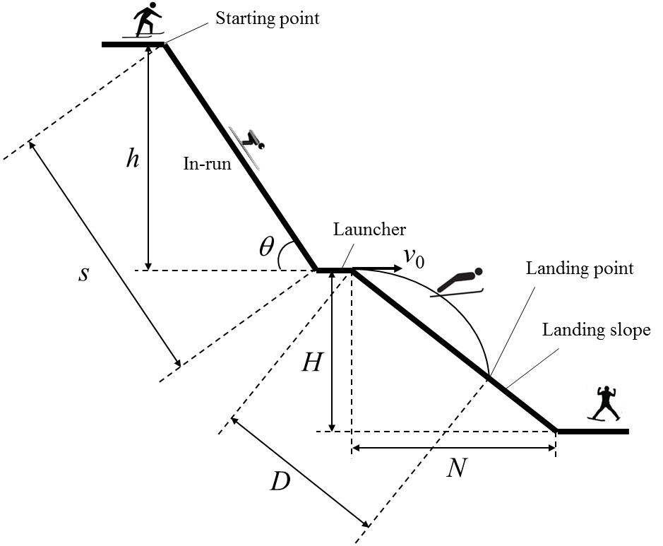
Figure II-1. Ski jumping

During the in-run the skier tries to maximize their acceleration by minimizing the friction in order to obtain the maximum in-run speed. This, in turn, has a significant influence on the jump length. θ, s, and h are the inclination angle, length, and height of the in-run, respectively. H and N are the height and horizontal length of the landing slope, respectively. Therefore, the gradient (k) of the landing slope is $k= \frac{H}{N}$ . We use g for the gravitational acceleration. Assume that the velocity (v_{o}) of the skier off the launcher is horizontal.

[Questions]

II-1. [0.75 points] Which of the following numbers represented the directions of the gravitational force, normal force, and air resistance, respectively, exerted on the skier during the in-run?

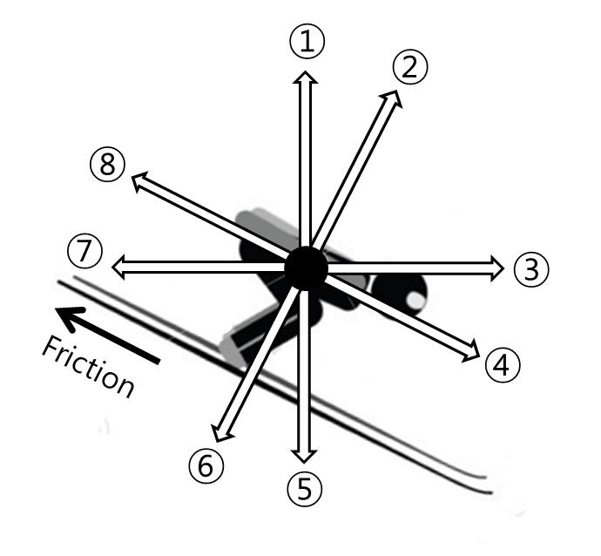

II-2. [1.5 points] If the speed of the skier is v at the bottom of the in-run, what is the coefficient (μ) of the kinetic friction between the ski and the snow? Express μ in terms of h, g, s, v, and θ. (Ignore the air resistance and lift.)

II-3. [1.5 points] If the launching speed of the skier is v₀ , what is the flight time (t) from the launcher to the landing point? Express t in terms of k , g , and v₀ . (Ignore the air resistance and lift.)

II-4. [1.25 points] What is the distance (D) between the launcher and the landing point? Express D in terms of k , g, and v₀ . (Ignore the air resistance and lift.)

III. Thomson’s Cathode-Ray Experiment

[Thomson’s Experiment]

In 1897, Thomson showed that a cathode ray is composed of negatively charged particles, electrons, which he calculated must have bodies much smaller than atoms and a very large value for their charge-to-mass (e/m) ratio, where e and m are the charge and mass of the electron, respectively.

Figure III-1 represents a schematic of Thomson’s cathode-ray experiment to measure e/m for an electron. In a highly evacuated vacuum tube, two sets of metal electrodes (L₁-M₁ and L₂-M₂) are placed normal to each other. The potential differences are V₁ between L₁ and M₁, and V₂ between L₂ and M₂, respectively. In the space between L₂ and M₂, a uniform magnetic field with strength B is directed perpendicular to the plane of the figure, pointing into the page (depicted by ‘X’ in the figure).
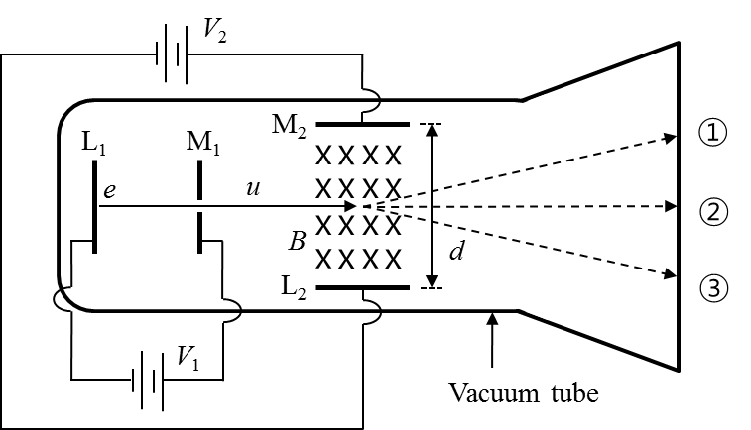
Figure III-1. Thomson’s experiment

When L₁ is heated, the electrons from the hot cathode (L₁) are accelerated by V₁ and pass with a speed of u through the slit in M₁. The electrons continue to fly in the region between L₂ and M₂ and finally strike the screen at the end of the tube. During the flight of the electrons between L₂ and M₂, separated by the distance d, only electric (field strength V₂/d) and magnetic (field strength B) forces exert on the electrons.

[Charge in Electric and Magnetic Fields]

Figure III-2 shows a particle with charge q in a uniform electric field between two parallel electrodes. The electric field strength (E) is determined by the distance (d) and electric potential difference (V) between the two electrodes as in equation (1). When the particle is placed in the electric field, the magnitude of the force exerted on the particle is given by equation (2). For a positively-charged particle, the potential energies of the particle are qV and 0 at the (+) and (–) electrodes, respectively.

$E=\frac{V}{d}$ (1)
$F_{electric}=qE$ (2)

Figure III-3 shows a positively-charged particle with charge q and speed u in a uniform magnetic field of field strength B. In the figure, the magnetic field is directed perpendicular to the plane of the figure, pointing out of the page (depicted by ‘∘’ in the figure). In this arrangement, the direction of the force exerted on the particle is upward and its magnitude is given by

$F_{magnetic}=quB$ (3)

Figure III-2. Charge in electric field Figure III-3. Positive charge in magnetic field

[Questions] Answer the following questions about Thomson’s experiment (Figure III-1).

III-1. [1.0 point] Express the speed of the electron u in terms of e, m, and V₁, at the moment the electron passes through the slit in M₁.

III-2. After the electron passes through the region between L₂ and M₂,

III-2-1. [1.0 point] If only an electric field is present, i.e. V₂ ≠ 0 and B = 0, which of ①, ②, and ③ in Figure III-1 would be the trace of the electron?

III-2-2. [1.0 point] If only a magnetic field is present, i.e. V₂ = 0 and B ≠ 0, which of ①, ②, and ③ in Figure III-1 would be the trace of the electron?

III-3. [1.5 points] Thomson adjusted the electric (V₂ ≠ 0) and magnetic (B ≠ 0) fields to let the electrons fly straight (trace ②) with a constant speed of u. Under this condition, what would be the speed of the electron u ? Express u in terms of V₂, B, and d.

III-4. [0.5 points] Compare the results of III-1 and III-3, then express the charge-to-mass ratio (e/m) for the electron in terms of V₁, V₂, B, and d.

IV. Excretory System

The table shows the constituents of samples collected from the nephron of a healthy human.

(unit: g/100mL)
Constituents | Blood plasma | Primitive urine  (glomerular filtrate) | Urine
Water | 90～93 | 90～93 | 95
X | 8 | 0 | 0
Y | 0.1 | 0.1 | 0
Minerals | 0.9 | 0.9 | 0.9～3.6
Z | 0.03 | 0.03 | 2.0

The figure shows an artificial hemodialyzer. (The permeability of the glomerular membrane and the hemodialyzer membrane is same.)

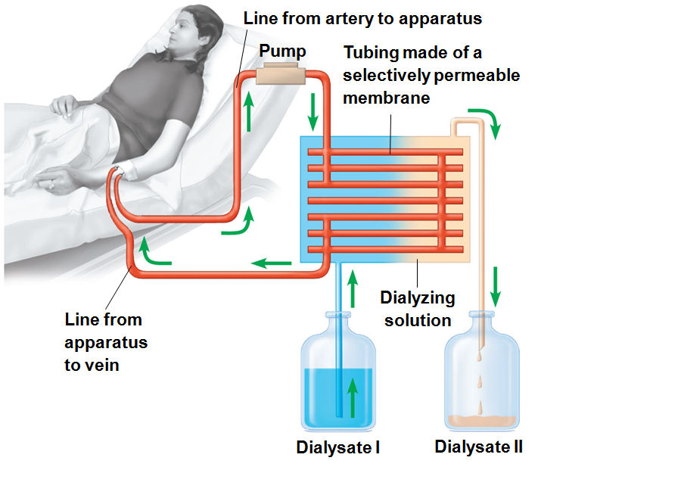

[Questions]

IV-1. [1.0 points] Which of the three parts of kidney indicated below plays a similar role as an artificial hemodialyzer?
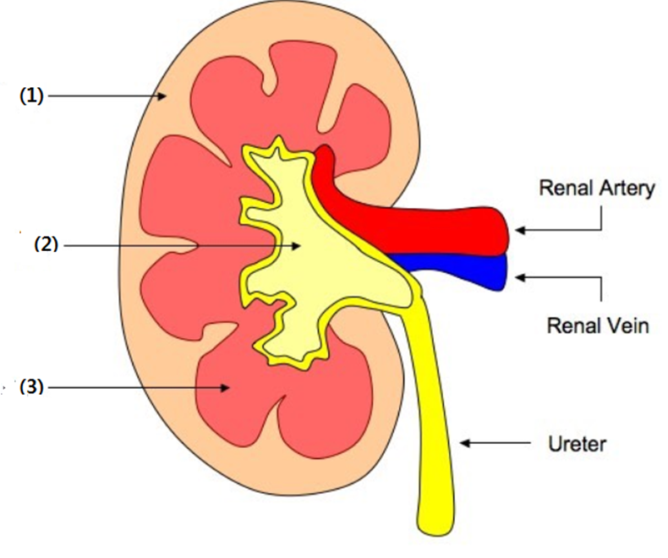

IV-2. [1.5 points] What are the concentrations of X, Y, and Z in dialysate I? (each answer 0.5 points)

IV-3. [1.5 points] Through which of the following processes (I, II and III) in a healthy human kidney do substances X, Y and Z go? (More than one option may be possible). (Each answer 0.5 points)

- Reabsorption II. Filtration III. Neither reabsorption or filtration

V. Genetics

While studying a common genetic condition in one family, it was found that the mutant allele differed from the wild-type allele by a single base-pair (bp) substitution. It was also noticed that this substitution removed the restriction enzyme I recognition site that is present in the wild-type allele. (This restriction enzyme recognizes a specific DNA sequence and cuts it. This sequence is called the ‘restriction enzyme recognition site’.) Figure V-1 is the pedigree of the family showing this genetic condition.

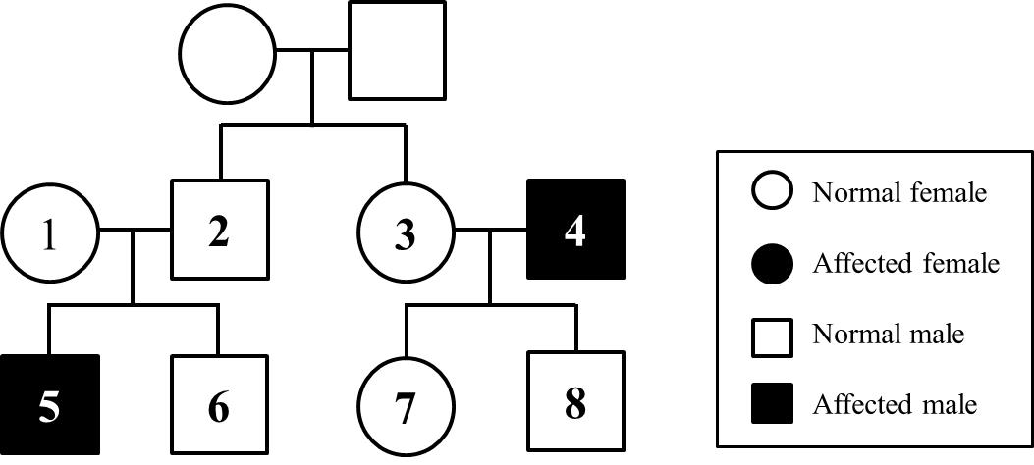
Figure V-1. Pedigree

After isolating DNA from four individuals (5, 6, 7, and 8) in the pedigree, 1500 bp of the DNA from each individual was amplified, including the site affected by the mutation, with a modern DNA technique. The amplified DNA was digested using the restriction enzyme I, and the resulting sizes of the DNA fragments were analyzed. The results of the DNA digestion experiments are summarized in Table V-1.

Table V-1. Results of DNA digestion experiments
Individuals |  | 5 | 6 | 7 | 8
Fragment sizes | 1500bp | + | – | + | +
 | 900bp | – | + | + | +
 | 600bp | – | + | + | +
(+ : present, – : absent)
[Questions]

V-1. [1.0 point] Based on the data, which of the following is the mode of inheritance of the genetic condition?

- X-linked dominant | ② X-linked recessive | - Y-linked dominant
④ Y-linked recessive | ⑤ Autosomal dominant | - Autosomal recessive
⑦ Mitochondrial inheritance

V-2. [1.0 point] If individuals 1 and 2 have another child, what is the probability that this child will be an affected female?

V-3. [1.0 point] The region around the restriction enzyme I recognition site in the amplified DNA from the wild type and the corresponding region in the amplified DNA of the mutant type were sequenced and compared. The experiment revealed that the mutation not only removed the restriction enzyme I recognition site in the mutant allele but also created a new restriction enzyme II recognition site. The recognition sites for the two restriction enzymes are indicated below.

Restriction enzyme I recognizes: 5’-TACGGT-3’
Restriction enzyme II recognizes: 5’-AGGTCA-3’

Based on the results, if a portion of one strand of the wild-type DNA sequence determined here is [5’-----TACGGTCA-----3’], what is the sequence of the corresponding portion of DNA in the mutant allele ?

VI. Blood Circulation

Figure VI-1 shows the changes of pressure and blood volume in the left ventricle over time.
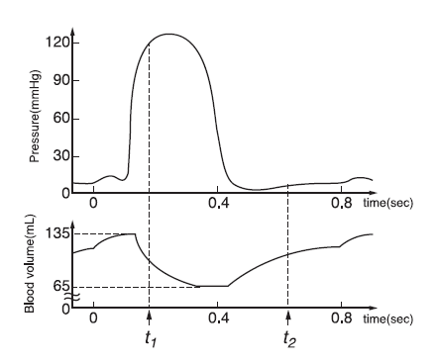
Figure VI-1. Changes of blood pressure and volume over time

[Questions]

VI-1. [1.0 point] At t₁ and t₂, indicate whether the left semilunar valve and left atrioventricular valve are open or closed. (Mark ‘○’ for open and ‘×’ for closed on the answer sheet.)

VI-2. [1.0 point] What is the heart rate (beats per min) depicted in Figure VI-1? (Answer it to a precision of two significant figures.)

VI-3. [1.0 point] The cardiac output is defined as the volume of blood pumped per ventricle per unit time. Calculate the cardiac output (L/min) in this condition? (Answer it to a precision of two decimal points.)

