

Multiple Choice Competition

**– Exam Sheet –**

December 4, 2015

|  |
| --- |
| **Do NOT turn to next page**  **before a whistle is blown.**  **Otherwise, you will receive a penalty.** |

|  |
| --- |
| **1. You have 10 minutes to read “EXAMINATION RULES”, “EXAM INSTRUCTIONS”, and “CALCULATOR INSTRUCTIONS” on pages 1 - 3.**  **2. Do NOT start answering the questions before the“START”whistle! Otherwise, you will receive a penalty.** |

**EXAMINATION RULES**

1. You are NOT allowed to bring any personal items into the examination room, except for personal medicine or approved personal medical equipment.

2. You must sit at your designated desk.

3. Check the stationery items (pen, calculator, and rough book) provided by the organizers.

4. Do NOT start answering the questions before the **“START”** whistle.

5. You are NOT allowed to leave the examination room during the examination except in an emergency in which case you will be accompanied by a supervisor/volunteer/invigilator.

6. Do NOT disturb other competitors. If you need any assistance, you may raise your hand and wait for a supervisor to come.

7. Do NOT discuss the examination questions. You must stay at your desk until the end of the examination time, even if you have finished the exam.

8. At the end of the examination time you will hear the **“STOP”** whistle. Do NOT write anything more on the answer sheet after this stop whistle. Arrange the exam, answer sheets, and the stationary items (pen, calculator, and rough book) neatly on your desk. Do NOT leave the room before all the answer sheets have been collected.

**EXAM INSTRUCTIONS**

1. After the “START” whistle, you will have 3 hours to complete the exam.

2. ONLY use the pen provided by the organizers (not pencil).

3. NOW write your name, code, country and signature in your answer sheet (one page). Raise your hand, if you do not have the answer sheet.

4. Read each problem carefully and indicate your answer on the answer sheet using a cross (as shown below). There is only one right answer for each problem.

*Example : (A) is your answer.*

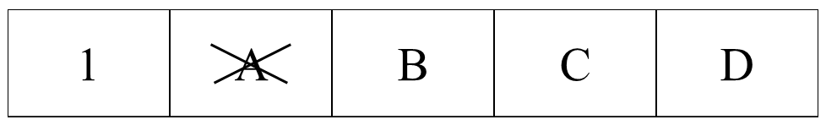

5. If you want to change your answer, circle your first answer and then indicate your new answer using a cross (as shown below). You can only make ONE correction per question.

*Example : (A) is your first answer and (D) is your final answer.*

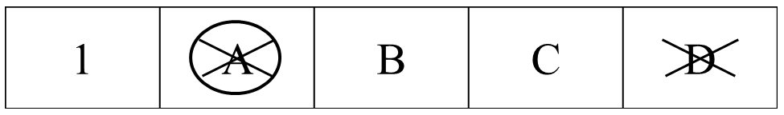

6. Only the answer sheet will be evaluated. Before writing your answers on the answer sheet, use the rough book provided.

7. Point rules

Correct answer : + 1 point

Wrong answer : − 0.25 point

No answer : no point

8. The total number of questions is 30. Check that you have a complete set of the test questions (23 pages, page 5 – page 27) after the **“START”** whistle is blown. Raise your hand, if you find any missing sheets.

**INSTRUCTIONS FOR CALCULATOR**

1. Turning on: Press .

2. Turning off: Press  .

3. Clearing data: Press .

4. Addition, subtraction, multiplication, and division

*Example 1) $45+\frac{285}{3}$*

* 45  285  3 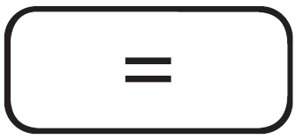* ***140.***

*Example 2)*

*  18  6    15  8  * ***3.428571429***

*Example 3) $42×\left(-5\right)+120$*

* 42  5   120 * ***-90.***

* 42    5   120 * ***-90.***

5. Exponential

*Example 1) ${8.6}^{-2}$*

* 8.6 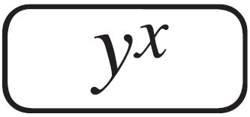 2  * ***0.013520822***

*Example 2) ${6.1 × 10}^{23}$*

* 6.1  10  23 * ***6.1 x 1023***

6. To delete a number/function, move the cursor to the number/function you wish to delete, then press . If the cursor is located at the right end of a number/function, the  key will function as a back space key.

|  |
| --- |
| **Do NOT turn to next page**  **Before the“START”whistle is blown.**  **Otherwise, you will receive a penalty.** |

**[ CHEMISTRY ]**

*Part of periodic table of elements, showing the atomic numbers and atomic symbols.

|  |  |  |  |  |  |  |  |
| --- | --- | --- | --- | --- | --- | --- | --- |
| 1  H |  |  |  |  |  |  | 2  He |
| 3  Li | 4  Be | 5  B | 6  C | 7  N | 8  O | 9  F | 10  Ne |
| 11  Na | 12  Mg | 13  Al | 14  Si | 15  P | 16  S | 17  Cl | 18  Ar |
| 19  K | 20  Ca | 31  Ga | 32  Ge | 33  As | 34  Se | 35  Br | 36  Kr |

**1.**

Below is incomplete information for neutral atoms I and II.

|  |  |  |
| --- | --- | --- |
| Atom | I | II |
| Number of protons |  | 7 |
| Number of neutrons | 7 | *a* |
| Number of electrons | 7 | *b* |
| Mass number |  | 15 |

Which of the following is correct?

(A) *a* = 7

(B) *b* = 8

(C) Atomic number of I is 14.

(D) I and II are isotopes of the same element.

**2.**

Which of the following is the correct order of the decreasing ionic radius for Na+, Mg2+, O2−, and F−?

(A) Na+ > Mg2+ > F− > O2−

(B) Mg2+ > Na+ > O2− > F−

(C) O2− > F− > Na+ > Mg2+

(D) F− > O2− > Mg2+ > Na+

**3.**

Which of the following molecules has a non-zero dipole moment?

(A) CO2 (B) CCl4 (C) C2H2 (D) H2Se

**4.**

The reaction rate is the change in concentration of a reactant or product with time, the unit of which is M/s. When the reaction rate depends on the *n*-th power to the concentration of a reactant, [R]:



where *k* is the rate constant, it is called an *n*-th order reaction. The following graph shows [R] as a function of time for the chemical reaction R → P. (P denotes the product). M = moles/litre

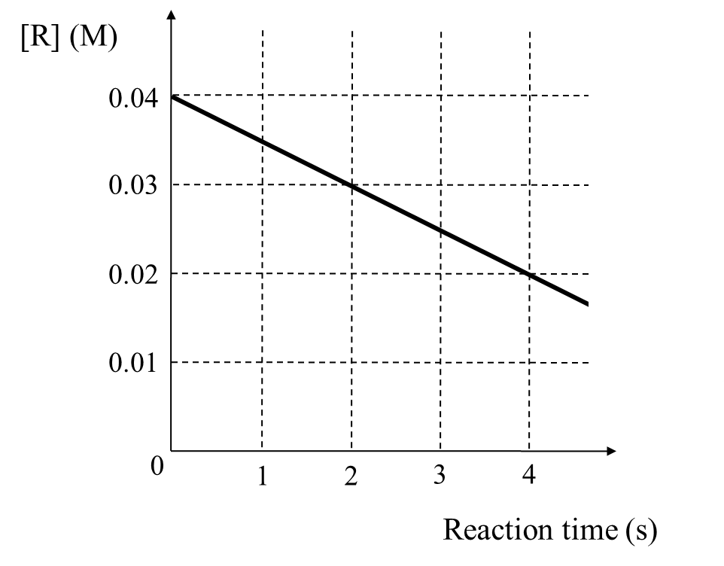

Which of the following is correct for both *n* and the unit of *k* for the reaction R → P?

(A) 0, 1/s (B) 0, M/s (C) 1, 1/s (D) 1, M/s

**5.**

A gaseous hydrocarbon **X** has a density of 1.25 g/L at 0 °C and under 1 atm. What is the mass fraction of carbon in **X**? (The atomic masses of carbon and hydrogen are 12.0 and 1.00 g/mol, respectively, and 1.00 mole of gas occupies a volume of 22.4 L at 0 °C and under 1 atm.)

(A) 75.0 % (B) 80.0 % (C) 85.7 % (D) 92.3 %

**6.**

What is the electron configuration for the most stable ion of aluminum?

(A) 1s22s22p63s2

(B) 1s22s22p6

(C) 1s22s22p53s1

(D) 1s22s22p63p2

**7.**

The standard enthalpy of formation () of a substance is the enthalpy change during a process, where the substance is formed from the most stable forms of the constituent elements at 1 atm. The following figure is the enthalpy diagram of N-, or O-containing compounds. ’s are the standard enthalpy changes for the corresponding processes at 25oC.



What is theof NO2(*g*) at 25 oC?

(A) 10 kJ/mol

(B) 510 kJ/mol

(C) −460 kJ/mol

(D) −1430 kJ/mol

**8.**

The table below shows the acid dissociation constant () of three chemical species at 25 °C.

|  |  |  |  |
| --- | --- | --- | --- |
| Species | HF | CH3COOH | HCN |
|  |  |  |  |

Which of the following options from A to D chooses all the correct statement(s) from the box below? (Assume that the temperatures of the solutions are kept constant at 25 °C.)

|  |
| --- |
| ① 0.1 M HCN(*aq*) is basic.  ② The pH of 0.1 M HF(*aq*) is lower than the pH of 0.1 M CH3COOH(*aq*).  ③ The concentration of H+ is higher in 1 M HCN(*aq*) than in 0.1 M CH3COOH(*aq*). |

(A) ① (B) ② (C) ①, ③ (D) ②, ③

**9.**

A U-shaped tube with a semipermeable membrane was filled with 2 L of water as shown in figure I. When 0.1 mol of **X** was completely dissolved in the right arm of the tube, the level of **X**(*aq*) solution has risen as shown in figure II. (Only water can pass through the membrane.)

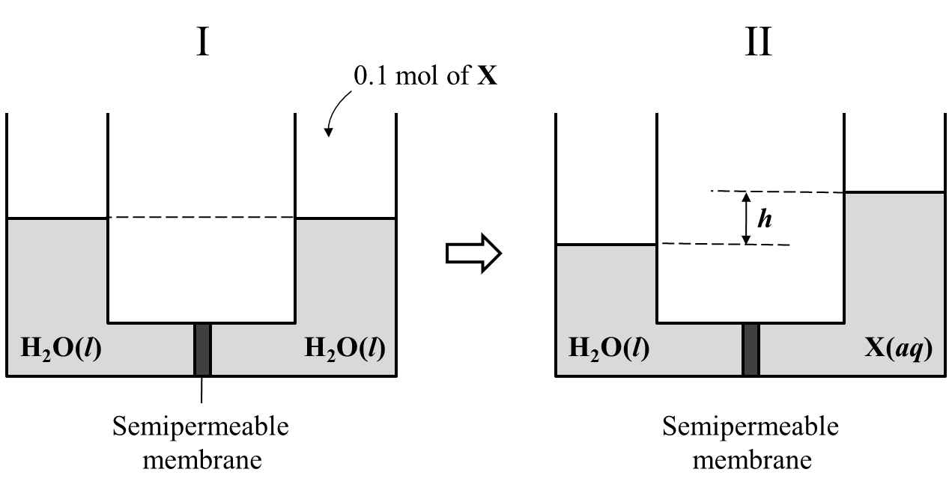

Which of the following **X** would give the SECOND greatest ***h***?

(A) MgSO4 (B) CH3COOH (C) CaCl2 (D) Sugar

**10.**

Rubber balloons **X** and **Y** were inflated with either pure H2 or pure Ne gas to the same volume of 10 L. After being left in air for 1 h, the balloons shrank such that balloon **X** had a larger volume than **Y**. (Assume that the ambient temperature and pressure were kept constant between *t* = 0 and *t* = 1 h.)

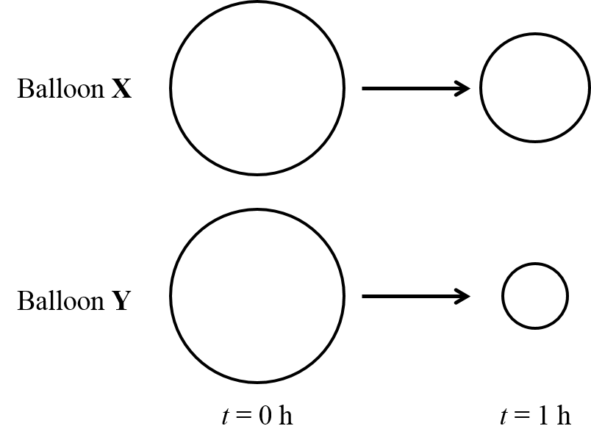

Which of the following options from A to D chooses all the correct statement(s) from the box below?

|  |
| --- |
| ① At *t* = 0 h, balloon **X** contained Ne.  ② Internal pressure of balloon **X** was constant throughout the above change.  ③ At *t* = 1 h, balloon **Y** contained a mixture of gases. |

(A) ① (B) ② (C) ①, ③ (D) ②, ③

**[ PHYSICS ]**

**11.**

Bats use ultrasonic waves to catch prey. When stationary, a bat emits ultrasonic waves of frequency 82.5 kHz. The bat now starts following a moth along the +x direction. The speeds of the bat and moth are 9.00 m/s and 8.00 m/s, respectively. The bat now emits and detects the wave reflected by the moth. The velocity of sound is 340 m/s.

Which of the following is the closest frequency for the detected wave by the bat?

(A) 82.7 kHz(B)82.8 kHz (C) 82.9 kHz (D) 83.0 kHz

**12.**

A ball of mass 1.0 kg is projected with a velocity of 10 m/s horizontally from the edge of a building at a height of 20 m. While falling, the ball splits into two identical pieces, X and Y without external forces. Then, X and Y hit the ground simultaneously at a point 10 m and *R* horizontally from the building, respectively. Consider the gravitational acceleration to be 10 m/s2 .

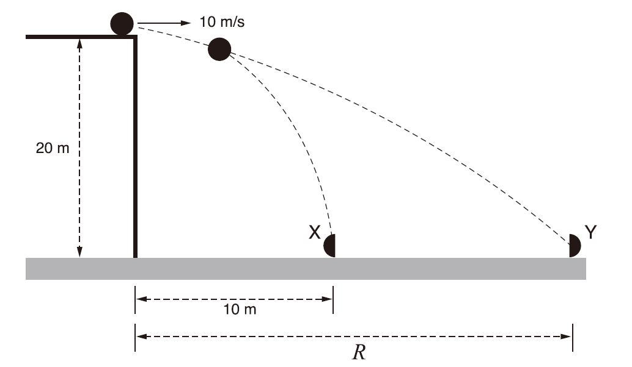

What is the distance *R*? (Assume there is no air resistance.)

(A) 20 m (B) 30 m (C) 40 m(D) 50 m

**13.**

A ball X with mass *m* travels on a frictionless track, as shown in the figure below. After barely rotating on a circular track of radius *R*, X collides with another ball Y, which has mass 2*m* and is initially at rest. After the collision, X and Y stick together and move.

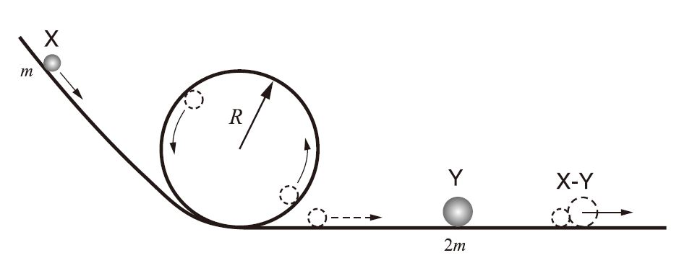

What is $\frac{K_{X}}{K_{XY}}$? ( $K_{X}$ and $K_{XY}$ are the kinetic energies of X just before the collision and of XY after the collision, respectively.)

(A) 1 (B) 2(C) 3(D) 4

**14.**

A block of mass *m* is released from one rim of a hemispherical bowl of radius *R*. In the presence of friction, the block finally stops at the bottom of the hemisphere after oscillating left and right.

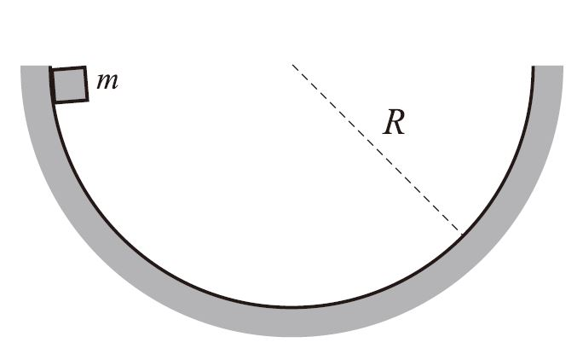

What are the amounts of the work done by gravitational and normal forces?

|  |  |  |
| --- | --- | --- |
|  | Work done by gravitational force | Work done by normal force |
| (A) | 0 | 0 |
| (B) | *mgR* | 0 |
| (C) | 0 | *mgR* |
| (D) | *mgR* | *mgR* |

**15.**

A tank is divided into two compartments X and Y with a thermally-insulating wall that can move without friction. X and Y contain an ideal gas at the same pressure *P*, volume *V*, and temperature *T* as shown in the figure below. After the temperature of X increases to 3*T*, the system reaches an equilibrium state. The temperature of Y remains constant at *T* throughout the time.

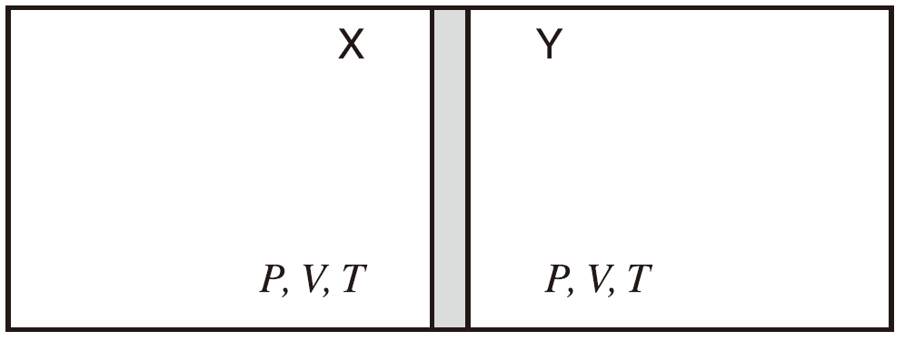

What is the gas pressure of Y at the equilibrium after the heating?

(A) *P*  (B) 1.5*P* (C) 2*P* (D) 3*P*

**16.**

A person takes a picture of a waterweed in a fishbowl using a camera with a convex lens. The fishbowl is filled with water of which the refractive index is $\frac{4}{3}$. When the film, lens, and waterweed are positioned as shown in the figure below, a clear image of the waterweed is recorded on the film.

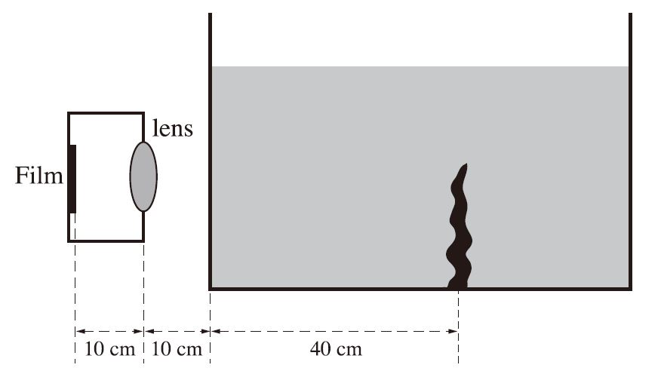

What is the focal length of the convex lens?

(A) 8.0 cm (B) $\frac{50}{6}$ cm (C) $\frac{110}{13}$ cm (D) 9.0 cm

**17.**

You see along the rim of a container so that the top rim is lined up with the opposite edge of the bottom (I). The container has a height of *H* and a width of 2*H*. While you keep your eye in the same position, your friend fills the container with a transparent liquid having a refractive index of *n*. Then you see a coin lying at point A (II).

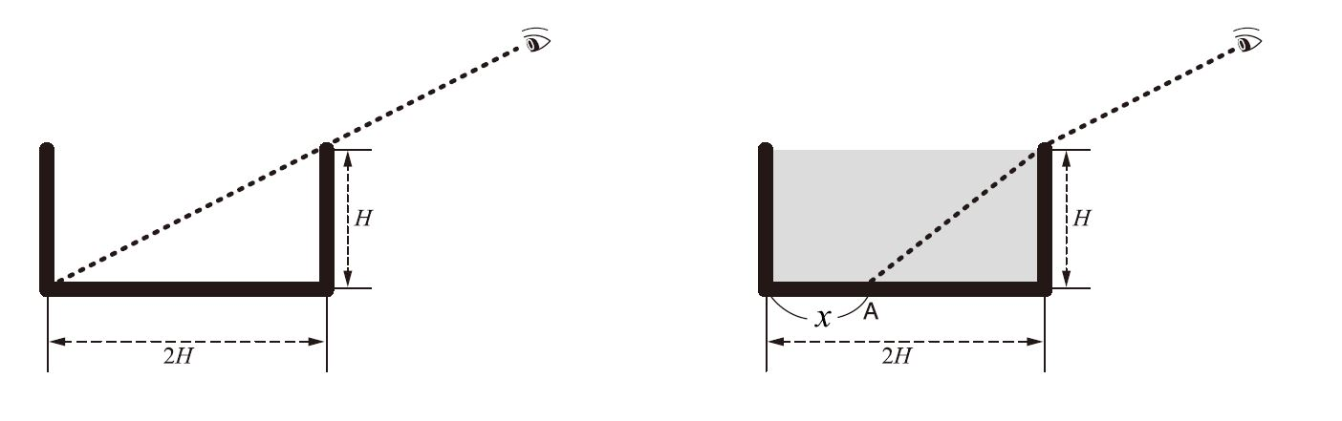

(I) (II)

What is *x*,the distance of the coin from the edge of the container?



$H \left(1-\frac{1}{\sqrt{3n^{2}-1}}\right)$

$2H \left(1-\frac{1}{\sqrt{3n^{2}-1}}\right)$

$H \left(1-\frac{1}{\sqrt{5n^{2}-4}}\right)$

$2H \left(1-\frac{1}{\sqrt{5n^{2}-4}}\right)$

**18.**

Two point charges X and Y are fixed at the same distance from the origin *O*. The charge of X is positive. When a negative charge is placed at point *P*, this negative charge does not move.

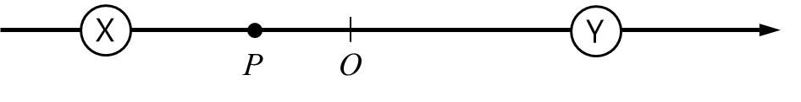

Which of the following sketches shows the correct electric field lines before placing the negative charge at *P*?

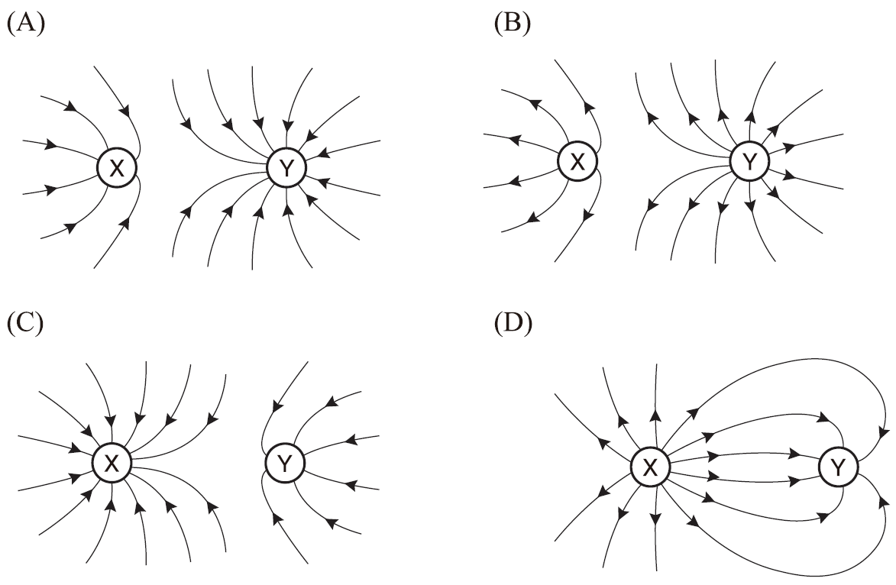

**19.**

The figure below is a circuit containing two batteries, five resistors, and one capacitor.

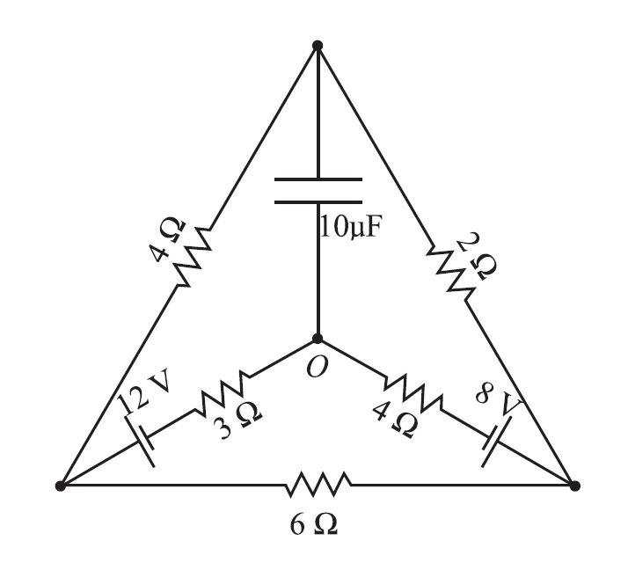

What is the current flowing through the 3 resistor after sufficient time has passed?

(A) 0.1 A (B) 0.2 A (C) 0.4 A (D) 0.8 A

**20.**

**The figure below shows two circuits containing solenoidal coils and LEDs (Light-Emitting Diodes). The colors of the LEDs in the left circuit are red and orange, and those in the right circuit are yellow and blue. The  LEDs turn on when the current flows to the right, while the  LEDs turn on when the current flows to the left. The magnet moves from side to side between the coils in the following sequence; O→P→O→Q→O. Assume that the current is only induced in the left coil when the magnet moves between O and P, and only in the right coil when the magnet moves between O and Q.**

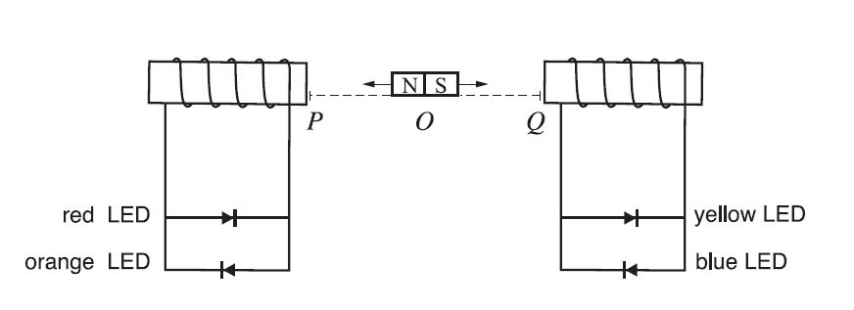

What is the turn-on sequence of the LEDs when the magnet moves in the sequence of *O*→*P*→*O*→*Q*→*O*?

(A) red – orange – yellow – blue

(B) orange – red – blue – yellow

(C) red – orange – blue – yellow

(D) orange – red – yellow – blue

**[ BIOLOGY ]**

**21.**

The pathways and reactions involved in the nitrogen cycle are complicated. The following describes some parts of the nitrogen cycle.

G:\21.tif

Which of the following options from A to D chooses all the correct statement(s) from the box below?

|  |
| --- |
| 1. Atmospheric nitrogen (N2) is fixed into organic molecules containing nitrogen by plants and humans. 2. X and Y are degradation processes by bacteria. 3. Z is a denitrification process by bacteria. 4. Plants are involved in the conversion pathways of NH4+ and NO3- to organic molecules containing nitrogen following the uptake of these ions |

(A) ①, ② (B) ①, ③ (C) ②, ③ (D) ②, ④

**22.**

The figure below shows the distribution of receptor cells X (solid line) and Y (dashed line) in the retina.

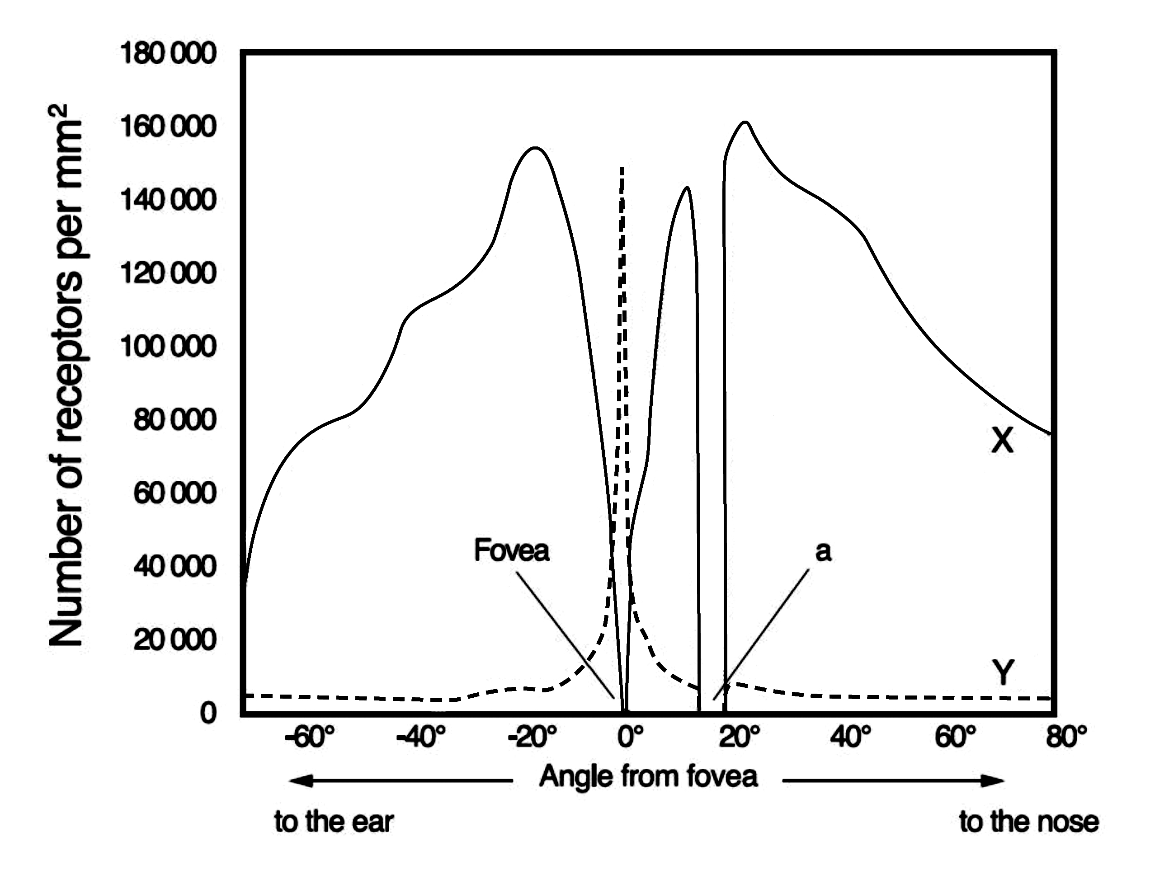

Which of the following options from A to D chooses all the correct statement(s) from the box below?

|  |
| --- |
| 1. X are usually located in the center of the retina. 2. X are less sensitive to light than Y. 3. “a” is the position of the blind spot. 4. is much higher in nocturnal (active in nighttime) animals than in diurnal (active in daytime) ones. |

1. ①, ② (B) ①, ③ (C) ②, ③ (D) ③, ④

**23.**

DNA is composed of two strands (I and II), and one of these strands can be used as a template to produce mRNA by the process of transcription. Consider a DNA fragment of 1000 base pairs. The base ratio of (A+T) : (G+C) in the strands is 1 : 4. The table below shows the base compositions of strands I and II, and the mRNA transcribed by one of the strands.

|  |  |  |  |  |  |  |  |
| --- | --- | --- | --- | --- | --- | --- | --- |
|  | | Base composition (number) | | | | | |
| G | A | T | C | U | Sum |
| DNA Strands | I |  |  | 150 |  |  | 1000 |
| II |  |  |  | 500 |  | 1000 |
| mRNA | |  |  |  | ( X ) | 150 | 1000 |

Which of the following statements is NOT correct?

(A) The number for X is 350.

(B) The number for A+G in strand I is 550.

(C) Strand II was used as the template for the mRNA.

(D) The total number of hydrogen bonds between A and T in the strands is 400.

**24.**

The figure below shows the process of egg production and early development of a healthy fertilized egg in the human reproductive system.

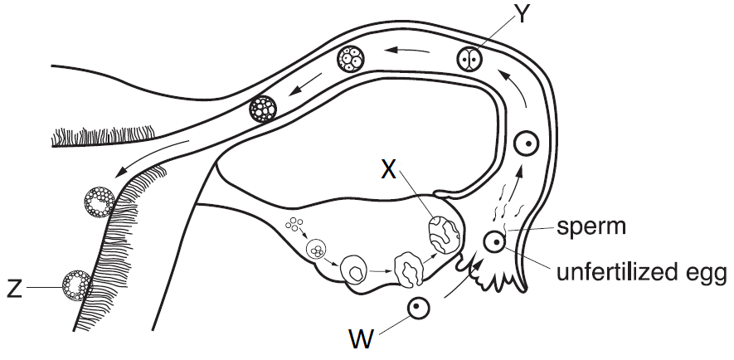

Which of the following statements is NOT correct?

(A) Three polar bodies are attached to W.

(B) X produces progesterone.

(C) The chromosome number for each cell in Y is 46.

(D) Z is at the stage of blastocyst

**25.**

Twenty flies are placed in each of the four sealed glass tubes (I –IV). While tubes I and II are partly covered with foil to protect from exposure to light, tubes III and IV are not covered. The numbers inside each tube of experiments 1 and 2 show the distribution of the flies immediately after the exposure to red light and blue light, respectively.

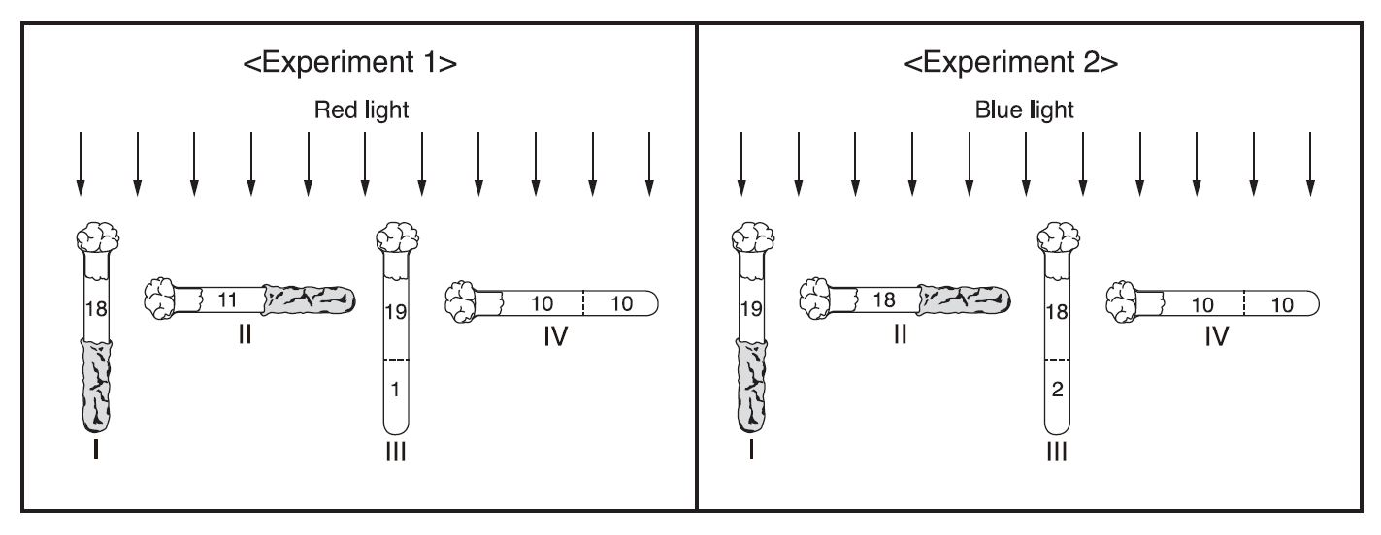

Which of the following statements about the experiments is NOT correct?

(A) The experiments are testing the response of the flies to red light, blue light and gravity.

(B) Tubes II and IV are serving as the controls for the light variable.

(C) Experiment 1 shows that flies respond to gravity, but not to red light.

(D) From experiments 1 and 2, it can be concluded that flies respond to blue light, but not to red light.

**26.**

The figure below shows a vein and contracted muscles surrounding the vein in the leg of a normal person.

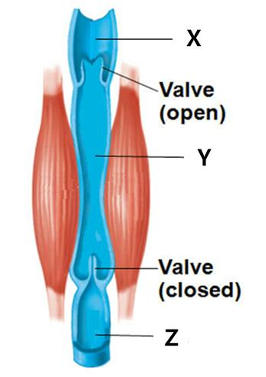

Which of the following options from A to D chooses all the correct statement(s) from the box below?

|  |
| --- |
| 1. The blood pressure at Y is higher than at X in this situation. 2. The blood flows from X to Y when the muscles relax. 3. The blood flows from Y to Z when the muscles contract. |

(A) ① (B) ② (C) ①, ③ (D) ②, ③

**27.**

The figure below shows the change of relative concentrations of antibody X’ and Y’ in the blood over time when animals are exposed to antigen X and Y. The animals have not been previously exposed to antigen X or Y.

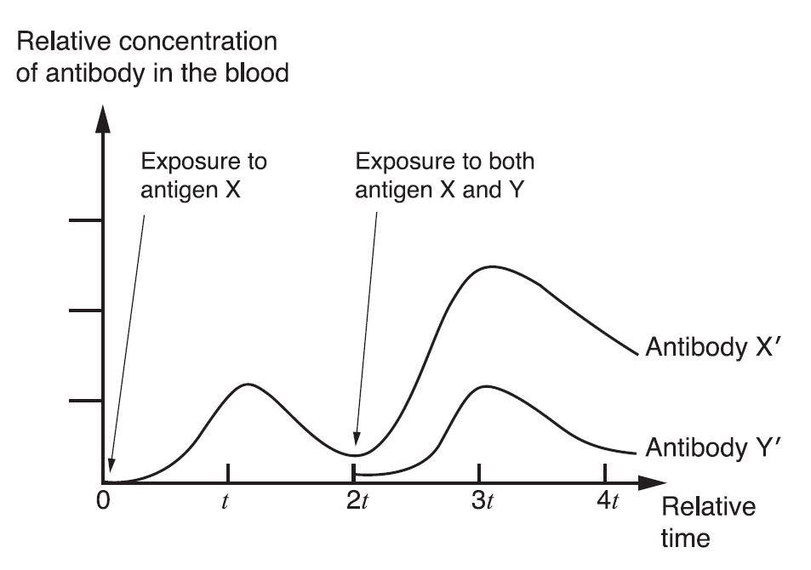

Which of the following options from A to D chooses all the correct statement(s) from the box below?

|  |
| --- |
| 1. Without antigen X, antibody Y´ would not be produced from 2*t* to 3*t*. 2. The rapid increase of antibody X´ from 2*t* to 3*t* is due to memory cellsagainst antigen X. 3. The increased production of antibody X´ from 2*t* to 3*t* is because antigen X and Y have acted together. |

(A) ① (B) ② (C) ①, ② (D) ②, ③

**28.**

The figure shows the structure and condensation states of a chromosome.

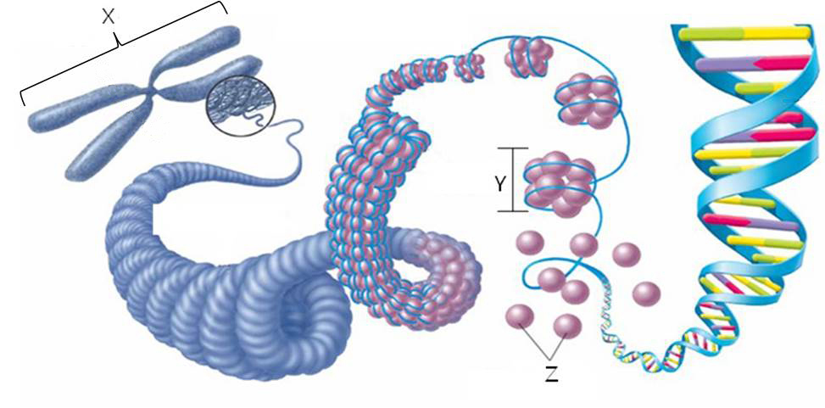

Which of the following options from A to D chooses all the correct statement(s) from the box below?

|  |
| --- |
| 1. X is observed in metaphase of the cell-division cycle. 2. Y is a nucleosome. 3. Bacteria have Z. |

(A) ① (B) ② (C) ①, ② (D) ②, ③

**29.**

The box below explains three cases of natural selection, and the figures show three different types of natural selection.

|  |
| --- |
| 1. The peppered moth gets its name from the peppery-looking coloration on its wings and body, which may be a light color or a dark color, with very few individuals being a color in between the two extremes. 2. Robins typically lay four eggs. A larger number of eggs may result in malnourished chicks, while a smaller number of eggs may result in no viable offspring. 3. Individuals of giraffe population with short necks could not reach as many leaves on which to feed. As a result, the distribution of neck length shifted to favor individuals with long necks. |

G:\그림3.tif

Which of the following figure-explanation matches is correct?

(A) I - ③ (B) II - ② (C) II - ① and ② (D) III - ① and ③

**30.**

The figures below show typical cells of three different living organisms (I, II, and III).

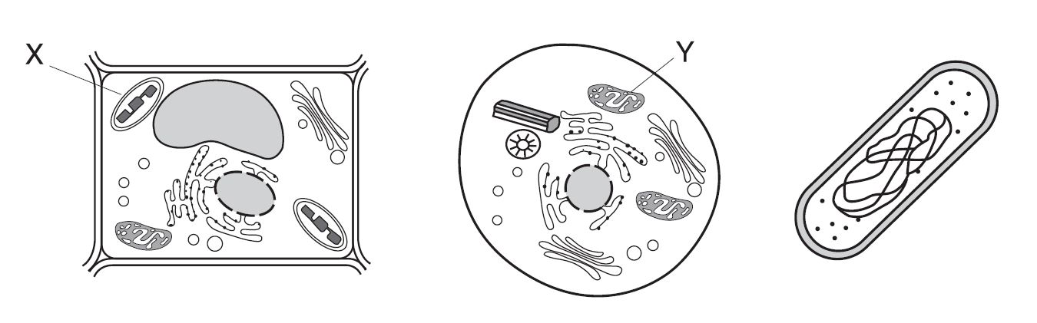

I II III

Which of following statements is correct?

(A) X in I is often found inside cyanobacteria.

(B) The cell wall can be observed in I and II.

(C) A nuclear envelope (membrane) encloses the nucleus in III.

(D) Genetic materials can be found in X and Y.