Experiment III. Anatomy and classification of fruits and seeds

III-1. [1.0 point](Answer): 0.5 points for correct drawing (separate sections and seeds) and 0.5 points for correct labeling.

III-1 | 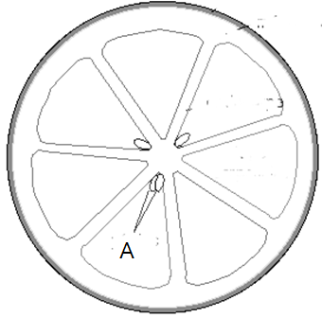

(Explanation) A is ovules which become seeds.

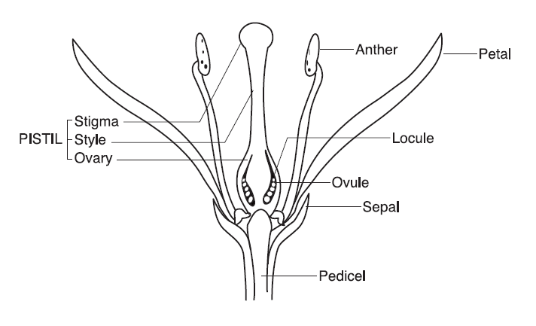
III-2. [2.5 point](Answer) = 4 x 0.5 points for correct labeling and 0.5 points for correct drawing (Seeds, stem and inner and outer fleshy tissue).

III-2 | 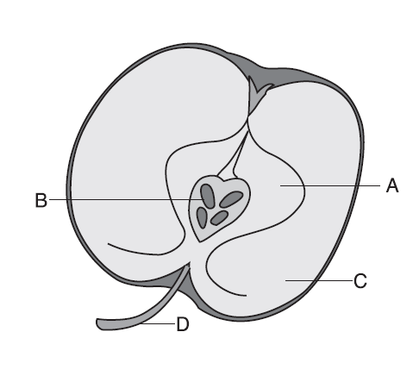

(Explanation)
A is originated from ovary, B from ovules, C from hypanthium, and D from pedicel.

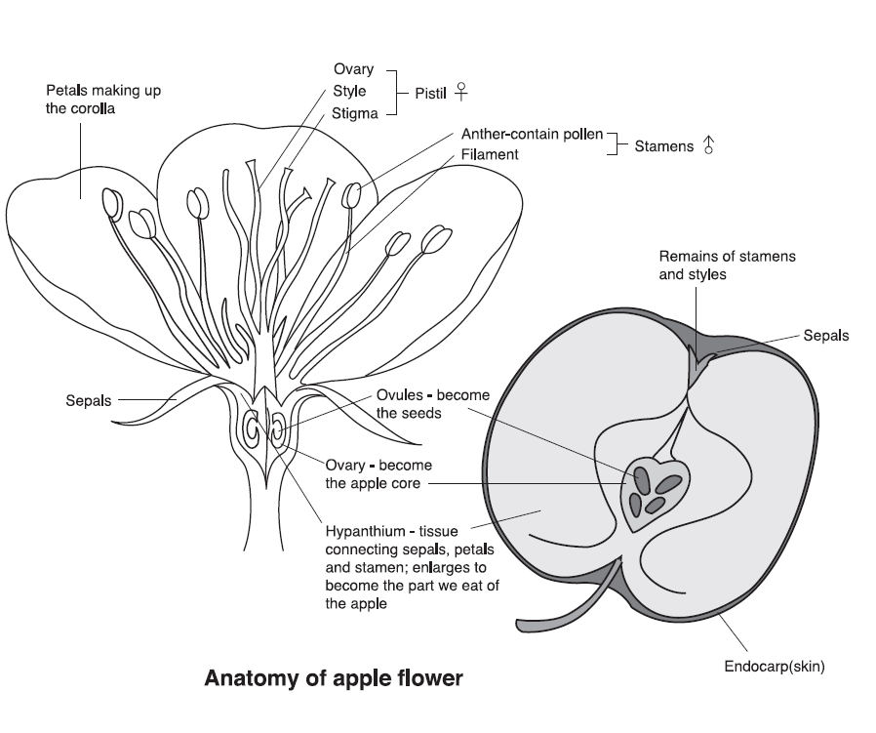

III-3-1. [2.0 points] (Answer) = 2 x 1 point
C | A

III-3-2. [2.0 point] (Answer) = 2 x 1 point
c | d
III-b | III-a

III-3-3. [4.0 points] (Answer)
0.5 points per correct fruit (column)
0.25 points for only one mistake per column.

Fruit  Classification | A  Acorn | B  Apple | C  Bean pod | D  Lychee | E  Lemon | F  Persimmon | G  Rice | H  Strawberry
Single seed fruit | √ |  |  | √ |  |  | √
Many seeded fruit |  | √ | √ |  | √ | √ |  | √
Aggregate fruit |  |  |  |  |  |  |  | √
Multiple fruit
True fruit | √ |  | √ | √ | √ | √ | √
Accessory fruit |  | √ |  |  |  |  |  | √
Fleshy fruit |  | √ |  | √ | √ | √ |  | √
Dry fruit | √ |  | √ |  |  |  | √

III-3-4. [1.5 points] Identify which fruits from box 1 most appropriately are represented by 3, 4, 5 and 6.
 |  | Points
3 | B, E, F in any order | 0.25 per correct fruit
4
5
6 | H | 0.75

